Circuit Analysis (Lab11)
Experiment 10: Verification of Norton’s Theorems

Name: Muhammad Zia Ur Rehman Zahid Registration NO: 2025-CE-104
Date: 15-May-2026 Grade and Signature: ……………………
CLO2 CLO3 | Use with identification the circuit components, breadboards, multimeter, power supplies, signal generators, and oscilloscopes. Make measurements in their own constructed electric circuits.
Psychomotor/Affective | Level1  (1) | Level2 (2-3) | Level3 (4-5) | Level4 (6-7)
Report Marks (3)
 | Total marks (10)

Objective
The objective of this lab is verify Nortan’s theorem and to find the full load current.

Apparatus Required
Sr. no | Apparatus | Range | Quantity
1 | Regulated Power Supply | Standard | 1
2 | Signal Generator | Standard | 1
3 | Oscilloscope | Standard | 1
4 | Digital Multimeter | Standard | 1
5 | Breadboard & Wires | Standard | As Required
6 | Resistors | 1k, 330 ohms | 1,3
7 | Potentiometer | Standard | 1
Description
Statement:
Any linear circuit can be simplified to an equivalent circuit consisting of a single current source and parallel resistance that is connected to a load.
Precautions:
- Voltage control knob of RPS should be kept at minimum position.
- Current control knob of RPS should be kept at maximum position

Procedure for Norton’s Theorem:
- Connections are given as per circuit diagram.
- Set a particular value in RPS and note down the ammeter readings in the original circuit.
To Find I_{N}:
- Remove the load resistance and short circuit the terminals.
- For the same RPS voltage note down the ammeter readings.
To Find R_{N}:
- Remove RPS and short circuit the terminal and remove the load and note down the resistance across the two terminals.
Equivalent Circuit:
- Set IN and RN and note down the ammeter readings.
- Verify Norton’s theorem.
To find load current in circuit 1:
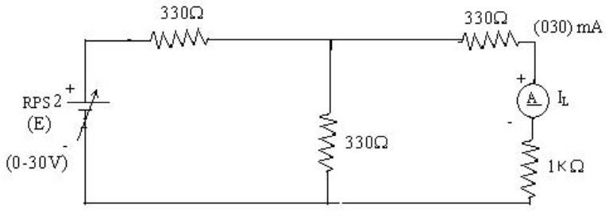
To find I_{N}
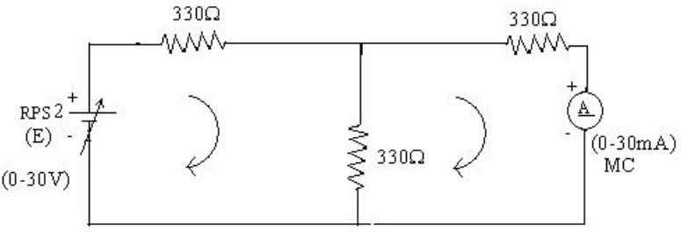

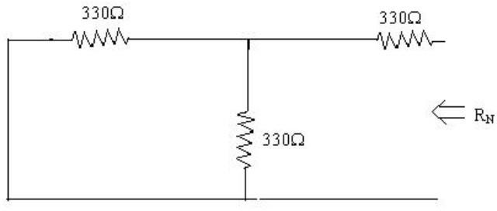
To find R_{N}

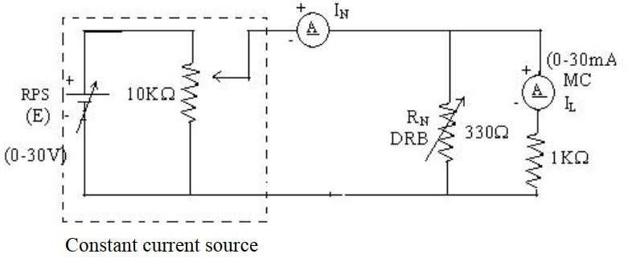
Norton’s equivalent circuit

Norton’s Practical Values
 | E (volts) | IN (mA) | Rn  (ohms) | IL (mA)
 |  |  |  | Circuit - I | Equivalent Circuit
Practical Values | 15V 15mA |  | 495 OHMS | 5.02mA | 5.02mA
5.

Post Lab Questions
1. What is Norton’s Theorem?
Norton’s Theorem states that any linear, bilateral network consisting of multiple voltage sources, current sources, and resistors can be replaced by an equivalent circuit consisting of a single constant current source IN in parallel with a single resistance RN
- IN Norton Current): This is the short-circuit current that flows through the load terminals when they are directly connected to each other.
- RN (Norton Resistance): This is the equivalent resistance of the network as seen from the load terminals, calculated by turning off all independent sources (short-circuiting voltage sources and open-circuiting current sources).

2. What are the applications of Norton’s Theorem?
Norton's Theorem is a powerhouse tool in circuit analysis, primarily used for:
- Load Analysis: It is ideal for circuits where the load resistance RL changes frequently. Instead of re-calculating the entire complex circuit, you only need to apply the current divider rule to the simple Norton equivalent.
- Circuit Simplification: It reduces highly complex networks into a two-component model, making it easier to visualize current flow.
- Power System Analysis: It is used to analyze large-scale power distribution networks and determine short-circuit currents for safety and fuse sizing.
- Source Transformation: It provides the mathematical basis for converting a Thevenin equivalent (voltage source) into a Norton equivalent (current source) and vice versa, which is a common trick to solve nodal analysis problems faster.

3. What are the theoretical and practical limitations of Norton’s Theorem?
Theoretical Limitations:
- Linearity Requirement: It only works for linear circuits. If the circuit contains non-linear components (like diodes, transistors in saturation, or thermistors), the theorem cannot be applied directly.
- Bilateral Components: It requires components to be bilateral (behaving the same regardless of current direction).
- Dependent Sources: While it works with dependent sources, they cannot be simply "turned off" like independent sources, making the calculation of RN significantly more complex.
Practical Limitations:
- Ideal vs. Real Sources: Theoretically, a Norton source provides constant current regardless of the load. In practice, real current sources (like the one you simulated in Proteus) have a maximum "compliance voltage" beyond which they cannot maintain the current.
- Power Dissipation: Calculating power in the Norton equivalent resistance RN does not represent the actual power dissipated in the original internal network; it only correctly predicts the power delivered to the external load.
- Measurement Errors: In a real lab (unlike Proteus), "short-circuiting" terminals to find IN can be dangerous if the current is too high, potentially blowing fuses or damaging components.

